Multi-genre Novel Study
Grade 7

What is a multi-genre paper?
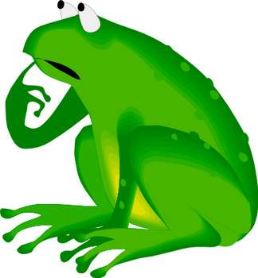

- A multi-genre paper is made up of different genres of writing.
- Each piece can stand by itself, but together, the pieces speak powerfully about the characters and themes your novel.
- Your pieces should work together to communicate (ideas, attitudes, themes, reactions) with the reader.
- During this project, you will be reading and responding to a book of your choice.
- You will learn about different writing styles and different genres, and will experiment with those genres by doing some creative writing.

What is a Genre anyway?

- A genre is a form of writing. Some examples are: plays, dialogues, magazine articles, poems, novels, and short stories.
- A genre can even be visual, such as a picture, collage, cartoon, illustration, etc.
- Some people express themselves best through other forms of representing text—you will have a chance to do this in this project
- We hope that by doing this project, you may find a number of new ways to connect with reading materials and other texts.

Things to remember:

- This is an independent home assignment so you will be doing most of the work at home.
- Some time will be given in class to work on the various projects (usually Wednesdays and/or Fridays) the dates will be set by your teacher.
- You will need to work on this project almost every day.
- Best strategy: Finish reading as early as possible and start planning your projects immediately. Watch the calendar and make the due dates.

How do I create a Multi-genre Paper?

MULTIGENRE ASSIGNMENT FORMAT | Points
TITLE PAGE: Creative visual design  - It should give the reader an indication of what is inside the project.  - It should be visually impressive and professional looking  - It must contain the following information: your name, teacher’s name, date, class, title of the novel, a visual design—avoid copying ideas from book covers or movies. | /5
INTRODUCTION--It is written for the benefit of the reader.  - It introduces the reader to the paper and explains what you selected to read.  - Discuss how you became interested in the topic and what you have learned about the topic.  - This should be about ¾ to 1 page in length (10-12 sentences). | /10
TABLE OF CONTENTS-Gives the title of your entries and lists the page numbers of each entry. | /5
MULTIGENRE SECTIONS:  Representing: Entry #1 Do one (1) of the following  - Create a poster based on the major conflict (s) in the novel  - Create a poster based the main character in the novel  - Create a poster based on the main events in the novel | /18
Writing: Five (5) entries (5pts. Each)  - One (1) entry must be 1 page in length. A feature article or a magazine article based on one of the main events or characters in the novel.  - One (1) Poetic entry (20 lines minimum) options include: free verse, found poetry, concrete poetry, lyrical ballad—a song, narrative poem.  - One (1) Journal entry 1 page in length. You may write from the point of view of a character in the novel. Focus on a major event.  - Two (2) entries are open—you decide what you want to say about your book. The entries can be songs, poems, essays, anything written. | /25
CONNECTORS: Six (6) transitional devices  - These connectors hold your paper together and provide a transition between the writing and representing entries of the project  - Connectors can be written or visual but must connect to your book in some way.  - You may use descriptive excerpts (dialogue, figurative language, etc.) from the book. You may also use visual designs (drawing, pictures, symbols, etc.)  - Be creative, use a variety of fonts, colors, images, and design techniques. | /12
Oral Presentation: 5 minutes maximum  Do one (1) of the following:  - Moviemaker with class introduction  - Dramatic presentation with costume  - Book talk with visual props | /25
FINAL MARK | /100

